**Лабораторная работа №2 ЗАПОМИНАЮЩИЕ ЭЛЕМЕНТЫ. ТРИГГЕРЫ**

**Цель:** изучить работу RS-триггера.

**Задание 1**

|  |  |  |  |
| --- | --- | --- | --- |
| R | S | Q(t) | Q(t + 1) |
| 0 | 0 | 0 | 0 |
| 0 | 0 | 1 | 1 |
| 0 | 1 | 0 | 1 |
| 0 | 1 | 1 | 1 |
| 1 | 0 | 0 | 0 |
| 1 | 0 | 1 | 0 |
| 1 | 1 | 0 | * |
| 1 | 1 | 1 | * |

**Задание 2**

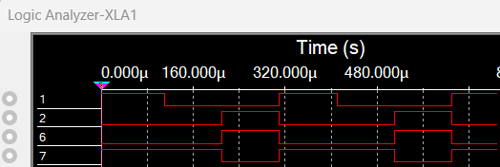

**Задание 3**

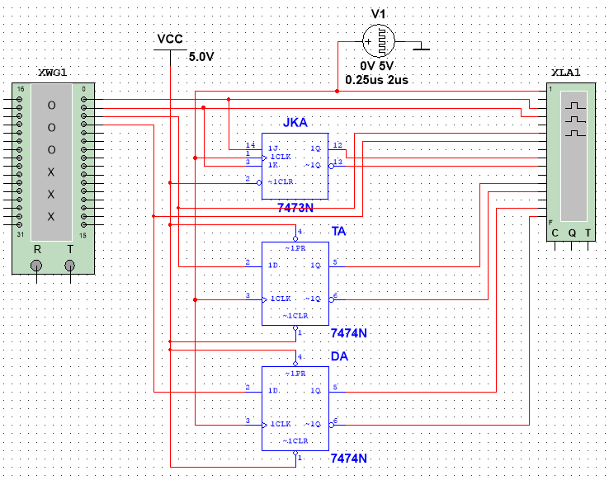

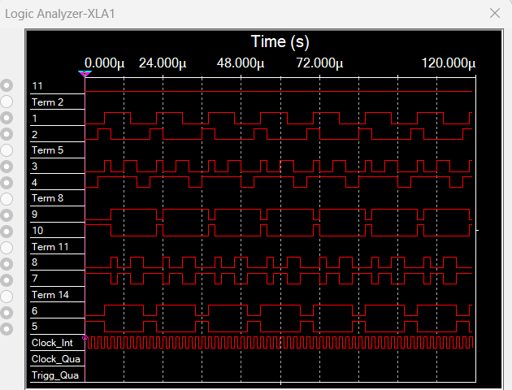

|  |  |  |  |
| --- | --- | --- | --- |
| J | K | Q(t) | Q(t + 1) |
| 0 | 0 | 0 | 0 |
| 0 | 0 | 1 | 1 |
| 1 | 0 | 0 | 1 |
| 1 | 0 | 1 | 1 |
| 0 | 1 | 0 | 0 |
| 0 | 1 | 1 | 0 |
| 1 | 1 | 0 | 1 |
| 1 | 1 | 1 | 0 |

|  |  |  |  |  |  |
| --- | --- | --- | --- | --- | --- |
| C | D | R | S | Q(t) | Q(t + 1) |
| 0 | X | 0 | 0 | Хранение | Хранение |
| 1 | 1 | 0 | 0 | 0 | 1 |
| 1 | 0 | 0 | 0 | 1 | 0 |

|  |  |  |  |
| --- | --- | --- | --- |
| C | D | Q(t) | Q(t + 1) |
| 0 | 0 | 0 | 0 |
| 0 | 0 | 1 | 1 |
| 0 | 1 | 0 | 0 |
| 0 | 1 | 1 | 0 |
| 1 | 0 | 0 | 0 |
| 1 | 0 | 1 | 0 |
| 1 | 1 | 0 | 1 |
| 1 | 1 | 1 | 0 |